**TP Modul 4 - Single Linked List (part 1)**

* list.h :

* list.cpp :

* main.cpp :

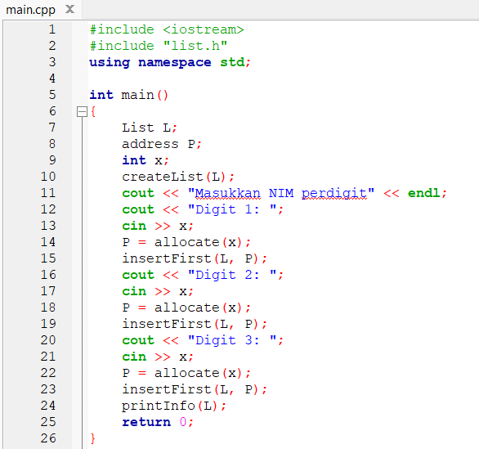

* output :

1. sesi have fun :

* list.h :

* list.cpp :

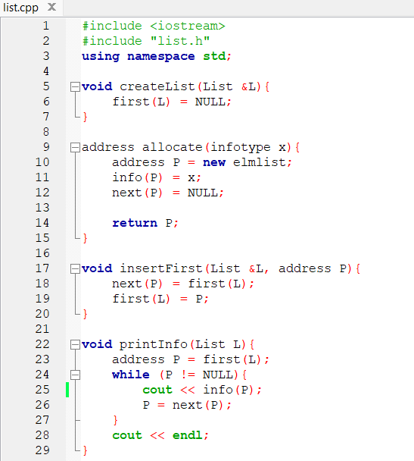

* main.cpp :

* output :

